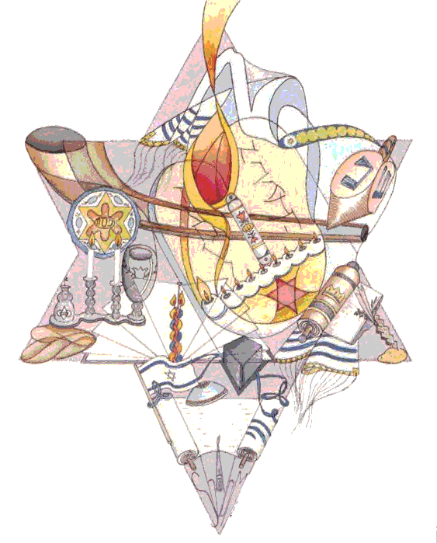
Chavurat Emet 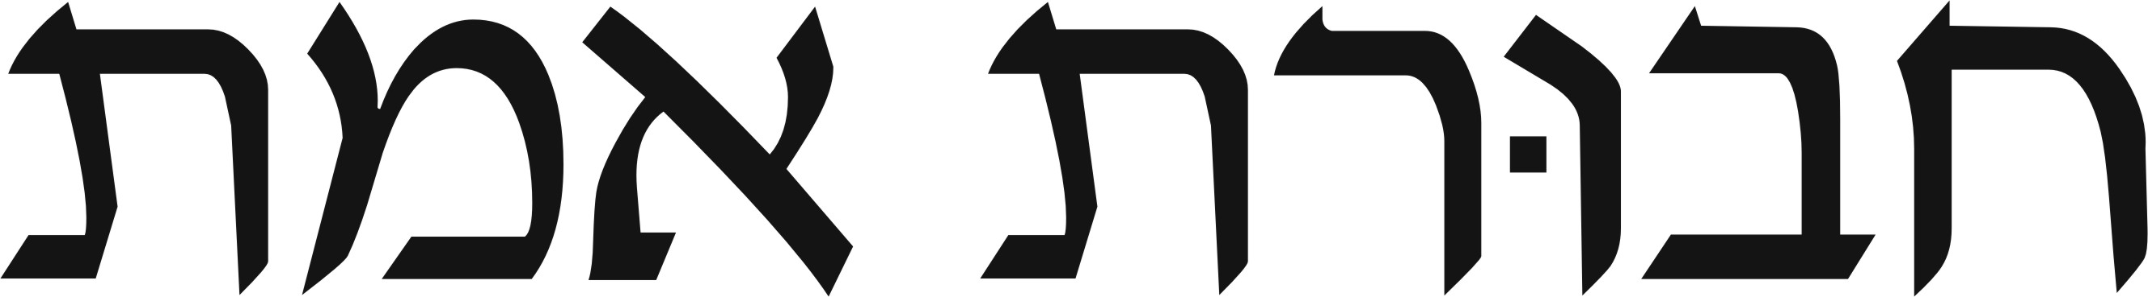

info@chavuratemet.org PO Box 461, Smithtown, NY 11787

Dear Chavurat Emet Members,

The High Holidays are coming soon and now is the time to think about honoring your departed family members. Consider joining the Chavurat Emet Memorial Program. This is a complete format which ensures that all aspects of your Yahrtzeit will be fulfilled.

The Chavurat Emet Memorial Program consists of the following:
- Your memorial plaque will be placed on our Memorial Board, which will include the name of the deceased and the English and Hebrew dates of death.
- You will receive a certificate acknowledging the plaque has been installed on our board.
- Our Spiritual Leader will recite the Kaddish at our service closest to the Yahrtzeit.
- A light on the Memorial Board will be lit in observance of the Yahrtzeit.
- The Memorial Board lights will all be lit in observance during the High Holidays.
- In advance of the deceased’s Yahrtzeit, Chavurat Emet will send you a reminder and a Yarhtzeit candle.

This total program is available to you for $180.
For further information or answers to your questions, please contact JoAnn Katz at 631-261-5089.

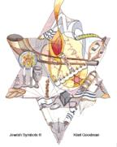
Chavurat Emet Memorial Board Order Form

Name ____________________________________________________________________

Address ____________________________________________________________________

____________________________________________________________________

Phone _________________________________________________

E-mail _________________________________________________

To add a plaque to the Memorial Board, mail this form and your check for $180 to Chavurat Emet, PO Box 461, Smithtown, NY 11787. Use one form per plaque. Please print.

NAME OF DECEASED ______________________________ RELATIONSHIP ______________

ENGLISH DATE OF DEATH ____________, ____, ________

HEBREW DATE OF DEATH ____________, ____, ________ (OPTIONAL)

